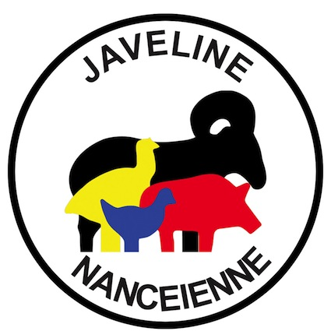 | LA JAVELINE NANCEIENNE  Tir Sportif (FFTir n° 1254012)  Siège : 15 Bd d’Haussonville F-54000 -NANCY  Courrier : La Javeline Nancéienne BP 83894 54029 NANCY Cedex  Président : Frédéric FEVE  Mail : javelinenancy@gmail.com  Portable : 06 48 38 25 11
 | Nancy, 07/02/2022

Dear shooter,
Our club is pleased to organize on septembrer 24th and 25th, 2022 a Friendly Challenge of Metallic Silhouettes. This challenge will be governed according to the official FFTir IMSSU rules (shooting 5 animals in 2 min, break 1min, shooting 5 animals in 2 min, for all disciplines, including the rifle) and will include the following disciplines:
Small Bore | Revolver  Production  Unlimited  Standing | Big Bore | Revolver  Production  Unlimited  Standing
FIELD PISTOL | Production  Optical | Rifle | Light Rifle 22LR  Silhouette Rifle22LR

Registrations duly completed with the names of the shooters and coaches must reach:
- By postal mail to LA JAVELINE NANCEIENNE BP 83894 54029 NANCY Cedex FRANCE
- Or email to javelinenancy@gmail.com

We draw your attention to the fact that the facilities and our organization allow us to achieve a maximum of 110 shots over two days across all disciplines. Thus, in case of excess number of shots, we will unfortunately be forced either to limit the number of shots per shooter, or to refuse registrations. Similarly, in case of high attendance, we can not guarantee cross coaching. Unlimited Big Bore will be shot on on Sunday afternoon.
Also, to allow us to satisfy everyone, you will want to respect the deadline for returning registrations:
imperatively by september 11th, 2022 at the latest

The entry price per discipline is 15 euros adjustable before the match. The coaches will lift up to 100m and mark the points. In the case of multiple shots for a tandem coach-shooter we will spread the matches over 2 days beyond 4 commitments for each of 2 in total. For the 3 aggregates Small Bore, Big Bore, and Standing, the 4th engagement by shooter will be offered.

If the timing allows, the ex-aequo will be separated by barrages posted at the stand. These barrages will be held by 2X5 animals, renewable 3 X maximum, if equality. In the opposite case, reverse count of animals if possible.

The award ceremony will take place on Sunday september 25th around 4 pm.

Looking forward to your reply, receive our best sports greetings.

Le Président
Frédéric FEVE
